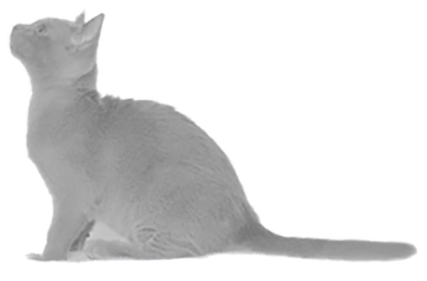
The Burmese Cat Club
Calendar 2024

The calendar is in the usual A4 portrait format.
The price of the calendar is £9.00 each including UK postage. For orders of 6 or more the price is reduced to £7.00 each including UK postage. For Overseas orders, please contact Sue Barker (contact details below) for costs.

Item | Quantity | Price | Total
Calendars (up to 5) |  | £9.00
Calendars (6+) |  | £7.00
 |  | Total payable

ORDER AND PAYMENT METHODS
By E-mail: Complete the form, scan it and email to Sue Barker at s.barker51@icloud.com. Alternatively, you can simply email Sue with your order making sure you give your full postal address including postcode. Payment may be made by electronic Bank Transfer. Please use the following Burmese Cat Club bank details when making the payment and insert your postcode in the payment reference box to enable the Club to trace your payment and match it to your order.

Burmese Cat Club
Sort code 09-07-26
Account number 52144004

By Post: complete the section below and send the order form with payment to:
Sue Barker, 51 West Close, Fernhurst, Surrey GU27 3JS.

I enclose cheque for £................. made payable to The Burmese Cat Club.
(Please complete this section in block capitals)

NAME ..............................................................................
ADDRESS .........................................................................
.........................................................................................
.........................................................................................
.........................................................................................
POSTCODE .......................................................................

Phone (in case of query) ..................................................
EmaiI ................................................................................

